**Description**

As a user, If I want to see who the team is and their project roles, I should be able to click on the Contact Link and be directed to that page.



⇧

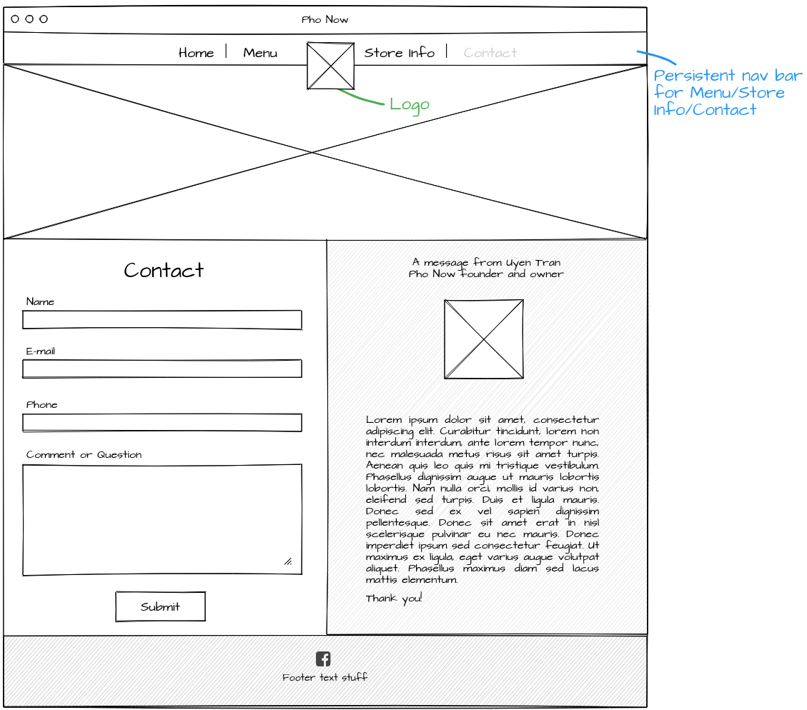

**Acceptance criteria**

* Display Contact form with Name , Email, Phone and Comments input fields.
* Display message from team (optional)
* Display Submit button.
* Mailing functionality should work.